***Python – mac changer***

Basic Mac changer:

Code:

**import subprocess**

**import optparse**

**def get_arguments():**

**parser = optparse.OptionParser()**

**parser.add_option("--i", "--interface", dest="interface", help="Interface to be selected for MAC address change")**

**parser.add_option("--m", "--mac", dest="mac", help="New MAC address")**

**return parser.parse_args()**

**def change_mac(intfc,new_mac):**

**# print("Changing mac addr for :" + str(intfc) + "to : " + str(new_mac) )**

**subprocess.call(['ifconfig', intfc, 'down'])**

**subprocess.call(['ifconfig', intfc, 'hw', 'ether', new_mac])**

**subprocess.call(['ifconfig', intfc, 'up'])**

**(options,arguments)=get_arguments()**

**intfc=options.interface**

**new_mac=options.mac**

**change_mac(intfc,new_mac)**

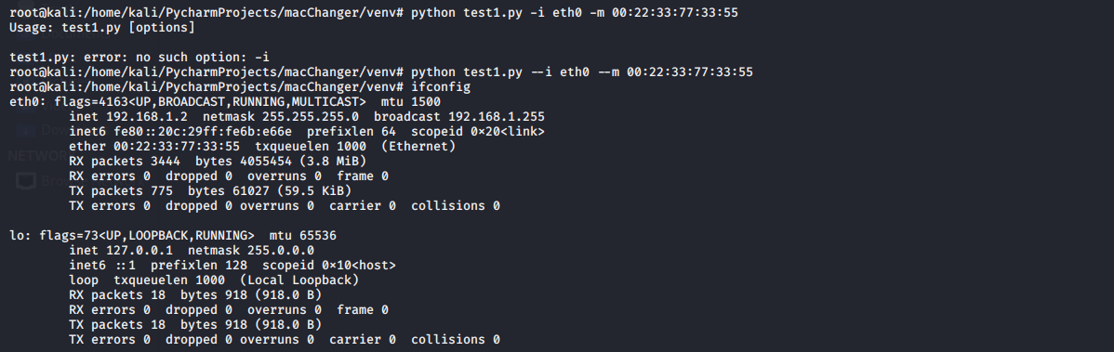

**Part 2 Checking THE ifconfig output**

**Subprocess check output**

**import subprocess**

**import optparse**

**import re**

**def get_arguments():**

**parser = optparse.OptionParser()**

**parser.add_option("--i", "--interface", dest="interface", help="Interface to be selected for MAC address change")**

**parser.add_option("--m", "--mac", dest="mac", help="New MAC address")**

**return parser.parse_args()**

**def change_mac(intfc,new_mac):**

**# print("Changing mac addr for :" + str(intfc) + "to : " + str(new_mac) )**

**subprocess.call(['ifconfig', intfc, 'down'])**

**subprocess.call(['ifconfig', intfc, 'hw', 'ether', new_mac])**

**subprocess.call(['ifconfig', intfc, 'up'])**

**(options,arguments)=get_arguments()**

**intfc=options.interface**

**new_mac=options.mac**

**ifconfig_result= subprocess.check_output(["ifconfig", intfc])**

**print(ifconfig_result)**

**PART 3**

**Using pythex regex for verification and comparison:**

**Write the regex from pythex site using cheatsheet**

**And implement in the following code:**

**def change_mac(intfc,new_mac):**

**# print("Changing mac addr for :" + str(intfc) + "to : " + str(new_mac) )**

**subprocess.call(['ifconfig', intfc, 'down'])**

**subprocess.call(['ifconfig', intfc, 'hw', 'ether', new_mac])**

**subprocess.call(['ifconfig', intfc, 'up'])**

**current_mac= get_mac(intfc)**

**if(current_mac):**

**print(current_mac)**

**if(options.new_mac == current_mac):**

**print(“Mac addr was successfully configured”)**

**else**

**print(“Sorry couldn’t change your mac address”)**